Need of static

Eg: Count_No_Of_Objects

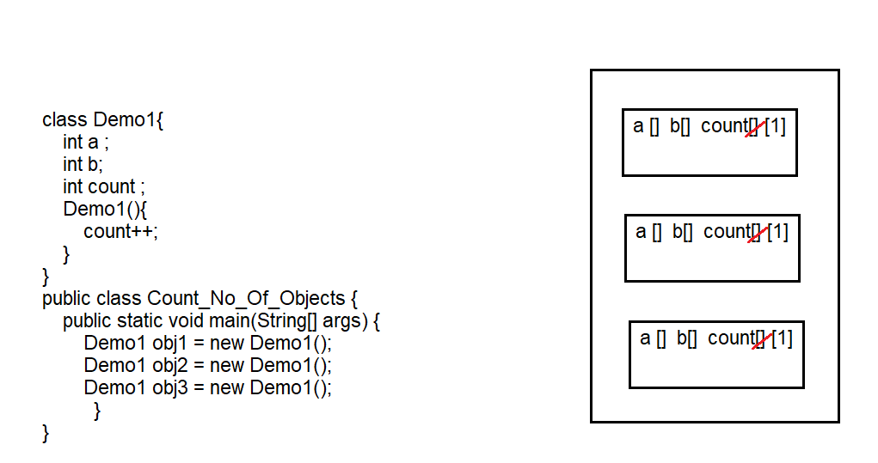

Here count is instance variable , memory is allocated every time the object is created . so cannot calculate the objects . the possible way is make count as static . then memory is allocated once and can be incremented every time when object is created .

Eg: Count_No_Of_Objects_Using_Static_Variable_In_Constructor

// here static variable count is written in constructor , if the variable is not written in one onn the constructors we cannot get the correct no of objects. And also size of program increases there by decreasing performance .

To overcome that

Note : which ever content is common is all the constructors include that in the non static block.

If it is kept in a static block it is executed only once . but java block will be executed no of times whenever object is created.

Eg: Count_No_Of_Objects_Using_Non_Static_Block

Explanation

Whenever constructor is executed , it will treat non static block as its body first executes it , and then executes the actual body.

Static variables memory is created once and can be used multiple times .

Non static block is executed even before constructor’s body . this() (or) super() should be the first one to be executed in constructor actual body . but even before that java block is executed first as a constructor body and then actual constructor body is executed .

Eg: java_block_Execution

Static variable :

1. static keyword is used
2. executed during class loading
3. memory is allocated in heap area
4. memory is allocated only once in heap .
5. one copy is used by all the objects
6. can be called using class name.
7. also called as class variables
8. object independent
9. can be used in static elements and non static elements

Note :

1. if something needs to be executed even before main method and during class loading , write them in static block , generally we use to initialize static variables .

Eg: Static_Block_Execution

1. if something need to be executed during object creation write them in constructor (or) non static block. And if there is some common statements in all the constructors write them in java block .

Eg: Static_Method

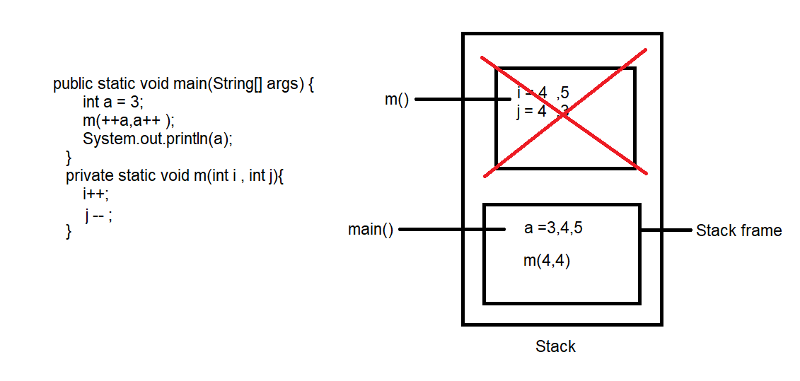

Here first main method is brought to stack frame and executed , method m() is called in main method , so another stack frame will be created for method m(), after the execution of method m() , it is removed from stack area , and local variables i,j has scope only until its execution completes . so a value is fetched from main method which is 5 .

Note : Pass by value : whenever you pass the data w.r.t variable , those changes will not be reflected in the memory (example above program there we passed values to method and there are not reflected in the memory )

Pass by reference :

Eg: Fizz here you are passing object references , whatever changes are made they are stored in the object and reflected in main method.